**Luther Home Christmas**

*Katie and Kids are decorating the Luther Home*

Katie: Soon it with be Christmas. Let’s all sing a Christmas Carol. *“O Come All Ye Faithful.”*

**O Come, All Ye Faithful**

1. Oh, come, all ye faithful,

Joyful and triumphant!

Oh, come ye, oh, come ye

To Bethlehem;

Come and behold him

Born the king of angels:

Oh, come, let us adore him,

Oh, come, let us adore him,

Oh come, let us adore him,

Christ the Lord!

2. Highest, most holy,

Light of light eternal,

Born of a virgin

A mortal he comes;

Son of the Father

Now in flesh appearing!

Oh come, let us adore him

Oh come, let us adore him

Oh come, let us adore him

Christ the Lord!

3. Sing choirs of angels

Sing in exultation

Sing all ye citizens

Of heaven above

Glory to God….

In... the... highest!

Oh, come let us adore him,

Oh, come let us adore him,

Oh come let us adore him,

Christ the Lord!

Katie: Let’s decorate the house…….

Kid: How? Flowers? Ribbons? Origami?

Kid: When is Dad going to be home?

Katie: Soon, I hope. He said he was bringing home something new for us. I wonder what it is?

Kid: Here he comes now!

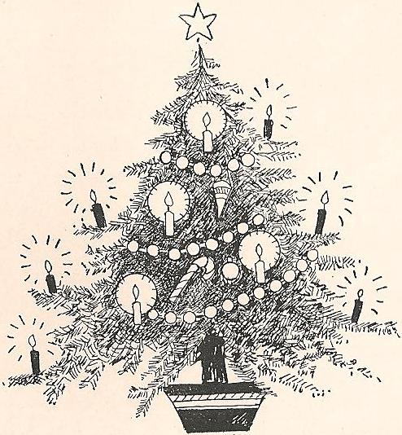

Martin: I’m home. Guten Abend!

Kid: Wha’ cha got there?

Martin: A Tree, a Christmas Tree!

Kid: Huh?

Martin: As I was coming home last night I saw the stars shining in the night sky. I thought they were like the Christmas Angels on the night Jesus was born. The stars were like many bright lights, like a million candles! The trees in the woods seemed to be full of stars, full of angels sitting on their branches! It was so beautiful I wanted to bring one of the trees home!

Kid: Huh?

Martin: We will put the tree in this stand here. And then we will put candles on the branches. It will look very pretty!

Katie: It will burn the house down!

Martin: We will be very careful. Look. I found a string of safety candles.

Kid: Huh? Where’d ja get those?

Martin: Columbus brought them back from America where they were invented by a man name Thomas Edison. They are on sale in Augsburg at the Euro Store!

Kid: Huh? Are you kidding? But they do look kool. What is this thing at the end of the string? These two shiny things? 口= [Or use a batter powered string with a battery box at the end with a switch. “What is this button?”]

Kid: Wow! It is magic!

Martin: No. It is science. We are in the 16th Century, you know! And besides, this is a play, you know. We can do anything!

Katie: Let’s sing that song they sing around the Christmas Tree in the village square by the Mall.  *“O Christmas Tree.”*

**O Christmas Tree**

O Christmas Tree, O Christmas tree,

How lovely are your branches!

O Christmas Tree, O Christmas tree,

How lovely are your branches!

In beauty green will always grow

Through summer sun and winter snow.

O Christmas tree, O Christmas tree,

How lovely are your branches!

Martin: I wrote a new Christmas song just for you, my children. It is about Christmas. It tells how the Christmas Angel visited the shepherds and told them the good news that Christ was born in Bethlehem.

Katie: Let’s not just sing, let’s act it out. Let’s put on some costumes.

Kid: I want to be an angel.

Kid: I want to be a shepherd.

Kid: I want to be Mary.

Kid: I want to be Joseph.

Kid: I just want to be a sheep, ba ba ba ba ba ba ba ba ba bah.

*All Move to Stage and Take Places*

*Hymn: “From Heaven Above”*

*Gabriel sings vs. 1-5 Or two angels can sing, 1-3 + 4-5*

*Shepherds sing vs 6-7*

*Congregation sings vs. 8-14.*

**From Heaven Above**

*The Angel Sings*

1 “From heav’n above to earth I come

to bear good news to ev’ry-one!

Glad tidings of great joy I bring

to all the world, and gladly sing:”

2 “To you this night is born a child

of Mary, chosen virgin mild;

this newborn child of lowly birth

shall be the joy of all the earth.”

3 “This is the Christ, God’s Son most high,

who hears your sad and bitter cry,

He will himself your Savior be

and from all sin will set you free.”

4 “The blessing that the Father planned

the Son holds in his infant hand,

that in his kingdom, bright and fair,

you may with us his glory share.”

5 “These are the signs that you will see

to let you know that it is he:

in manger-bed, in swaddling clothes

the child who all the earth upholds.”

*The Shepherds Sing*

6 How glad we’ll be to find it so!

Then with the shepherds let us go

To see what God for us has done

In sending us his own dear Son.

7 Look, look, dear friends, look over there!

What lies within that manger bare?

Who is that lovely little one?

The baby Jesus, God’s dear Son.

*The Congregation Sings*

8 Welcome to earth, O noble Guest,

through whom this sinful world is blest!

You turned not from our needs away;

how can our thanks such love repay?

9 O Lord, you have created all!

How did you come to be so small,

to sweetly sleep in manger-bed

where lowing cattle lately fed?

10 Were earth a thousand times as fair

and set with gold and jewels rare,

still such a cradle would not do

to rock a prince so great as you.

11 For velvets soft and silken stuff

you have but hay and straw so rough

on which as king so rich and great

to be enthroned in humble state.

12 Ah, dearest Jesus, holy child,

prepare a bed, soft, undefiled,

a holy shrine, within my heart,

that you and I need never part.

13 My heart for very joy now leaps;

my voice no longer silence keeps;

I too must join the angel-throng

To sing with joy his cradle-song.

14 “Glory to God in highest heav’n,

who unto us the Son has giv’n.”

With angels sing in pious mirth

a glad new year to all the earth!

Katie: Nice song, Martin. But I want to tell why Jesus was born in Bethlehem. You see, Bethlehem was the old home town of King David. And Jesus was the great, great X28 great grandson of King David. But Jesus was not just a prince, he was the Messiah King promised by God who would save his people from their sin. So Jesus had to be born and be registered in the Town of David so that everything would be nice and right and legal. Jesus would have a strange throne though, it would be a cross with a crown of thorns when he died on the cross. But he rose on the third day so we know that he really is the Messiah King, the Son of God!

Katie: There is a song about Bethlehem. Shall we sing it? “*O Little Town of Bethlehem.”*

**O Little Town of Bethlehem**

1 O little town of Bethlehem,

How still we see thee lie!

Above thy deep and dreamless sleep

The silent stars go by;

Yet in the dark streets shineth

The everlasting Light;

The hopes and fears of all the years

Are met in thee tonight.

2 For Christ is born of Mary,

And gathered all above,

While mortals sleep, the angels keep

Their watch of wond’ring love.

O morning stars, together

Proclaim the holy birth,

And praises sing to God the King,

And peace to men on earth!

3 How silently, how silently

The wondrous gift is giv’n!

So God imparts to human hearts

The blessings of His heav’n.

No ear may hear His coming,

But in this world of sin,

Where meek souls will receive Him, still,

The dear Christ enters in.

4 O holy Child of Bethlehem!

Descend to us, we pray;

Cast out our sin, and enter in,

Be born in us today!

We hear the Christmas angels

The great glad tidings tell;

O come to us, abide with us,

Our Lord Immanuel!

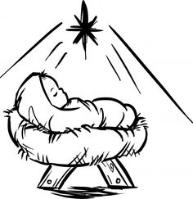

Kid: So Mary and Joseph traveled to Bethlehem. All the hotels and inns were full. There was no vacancy. So they slept in a barn, a stable, where Jesus was born and laid in the manger.

Kid 2: I know that song! “Away in a Manger.” Did you write that song Dad?

Martin: No, but is a really nice song, isn’t it?! ☺

Kid: Let’s sing it anyway!

*Hymn: “Away in a Manger”*

**Away in The Manger**

1

Away in a manger, no crib for a bed,

The little Lord Jesus

laid down His sweet head:

The stars in the sky

looked down where He lay;

The little Lord Jesus,

asleep on the hay.

2

The cattle are lowing, the Baby awakes,

But little Lord Jesus,

no crying he makes;

I love Thee, Lord Jesus!

look down from the sky,

And stay by my cradle

till morning is nigh.

3

Be near me, Lord Jesus,

I ask Thee to stay

Close by me forever,

and love me I pray;

Bless all the dear children

in Thy tender care,

And take us to heaven

to live with Thee there.

Martin: The house looks beautiful. Thanks kids, and you too, Katie. Let’s have a Christmas Prayer. I think it would be nice if each of us could add a line to it. Okay?

Kid: Dear Father in heaven….

Kid: Thank you for…….

Kid: Please ……..

Kid: Amen.

Kid: Can we sing one more song? I want to sing that Angel song, “Glooooooooori.”

Martin: Okay, everyone. Take your places again.

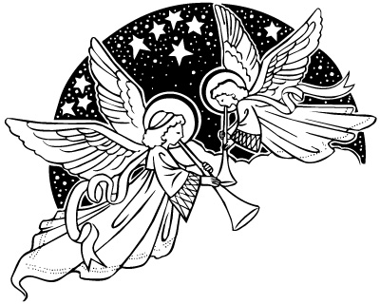

*Sing “Angels We have Heard on High.”*

*Angels sing verse one. Everyone joins in the chorus.*

*Shepherd sings verse two. Everyone joins in the chorus.*

*Mary and Joseph sing verse three. Everyone joins in the chorus.*

**Angles We Have Heard on High**

1 Angels we have heard on high,

Sweetly singing o’er the plains:

And the mountains in reply,

Echoing their joyous strains.

*Chorus*

Gloria in excelsis Deo!

Gloria in excelsis Deo!

2 Shepherds, why this jubilee?

Why your joyous strains prolong?

What the gladsome tidings be

Which inspire your heav’nly song? *Chorus*

3 Come to Bethlehem, and see

Him whose birth the angels sing;

Come adore on bended knee

Christ the Lord, the newborn King. *Chorus*

4 See Him in a manger laid,

Whom the choirs of angels praise;

Mary, Joseph, lend your aid,

While our hearts in love we raise. *Chorus*

id: I’m hungry. Let’s go downstairs and have some Christmas Cookies.

Martin: Yes! Go in peace. Serve the Lord.

Everyone: Thanks be to God!

*All Exit down center aisle.*

*The End.*

*Okinawa Lutheran Church*

*MN 2017*